**APTECH URC** 

**APTECH URC – APTECH COMPUTER EDUCATION**

# USER GUIDE FOR PATRONA PUPPY WEBSITE

1. **System Requirement**

|  |  |  |
| --- | --- | --- |
| **No** | **Software** | **Description** |
| **1** | Operating system | Windows 7 or higher |
| **2** | Hardware | Intel Pentium 4 processor or higher  512 Megabytes of RAM or higher |
| **3** | Software | Visual Studio Code |
| **4** | Web browser | Internet Edge , Chrome, Firefox |

1. **Introduction and website installation**

* This document is created to guide users use the website – **Patrona Puppy** effectively. It is advisable that users should read this document before starting to use this website in reality.
* To run**Patrona Puppy** website, users need to do the following steps:
  + 1. Extract the file rar: *eProject – Patrona Puppy by Group 1( Aptech URC)*
  1. Open the folder *eProject.*

* 1. Open index.html file to start the website. Look at figure 2 for illustration

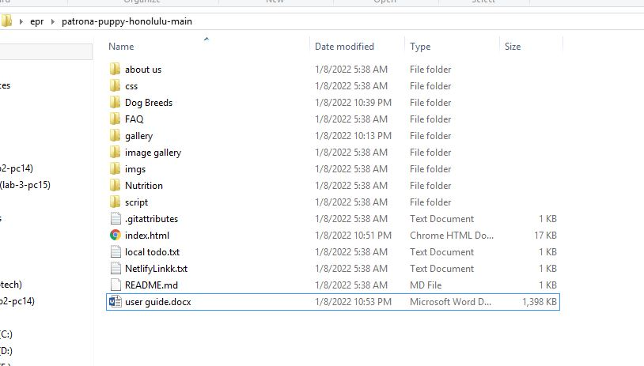

Figure 2

* 1. If done successfully, users will see the Homepage like figure 3 as below. At this page, you will have information about history of the website.

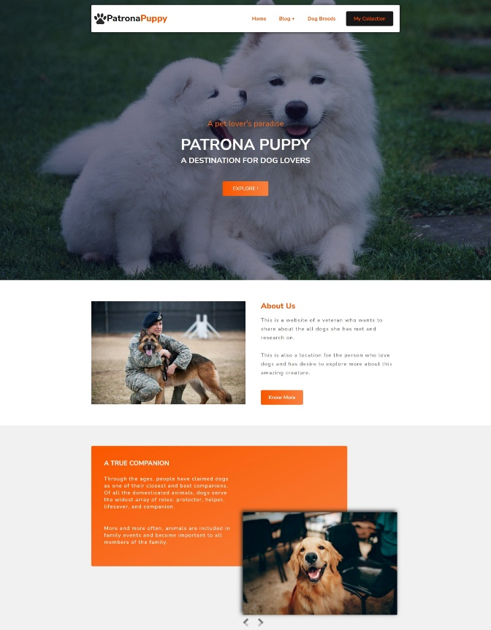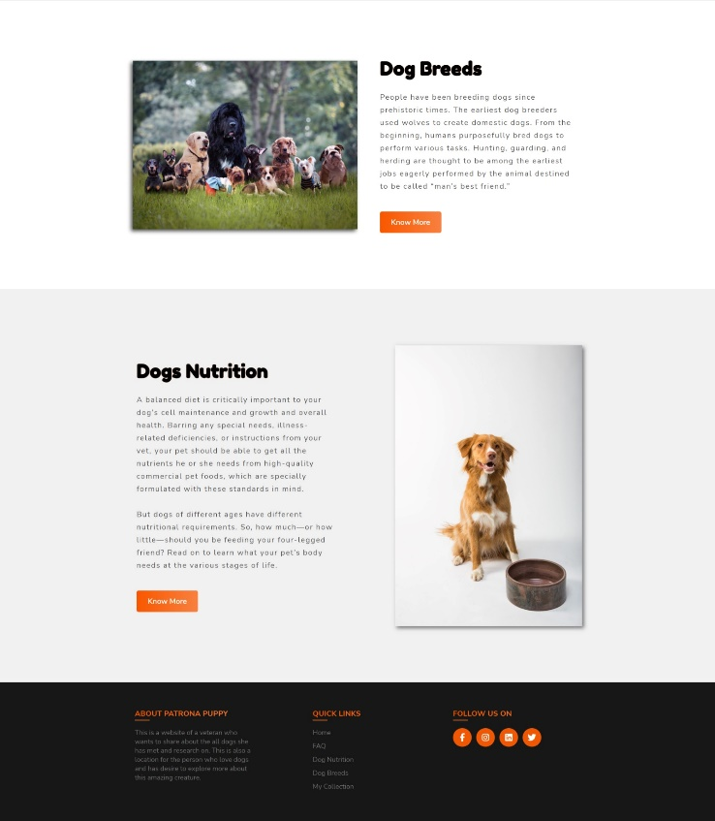

Figure 3

## Dog Breeds

The **Dog Breeds** webpage allows users to find the information about 36 dog breeds (Figure 4). To get the details of a particular dog, users need to click on the button “Read more”, which will automatically open the information page for that dog. For example, figure 5 illustrates detailed information for Cane Corso.

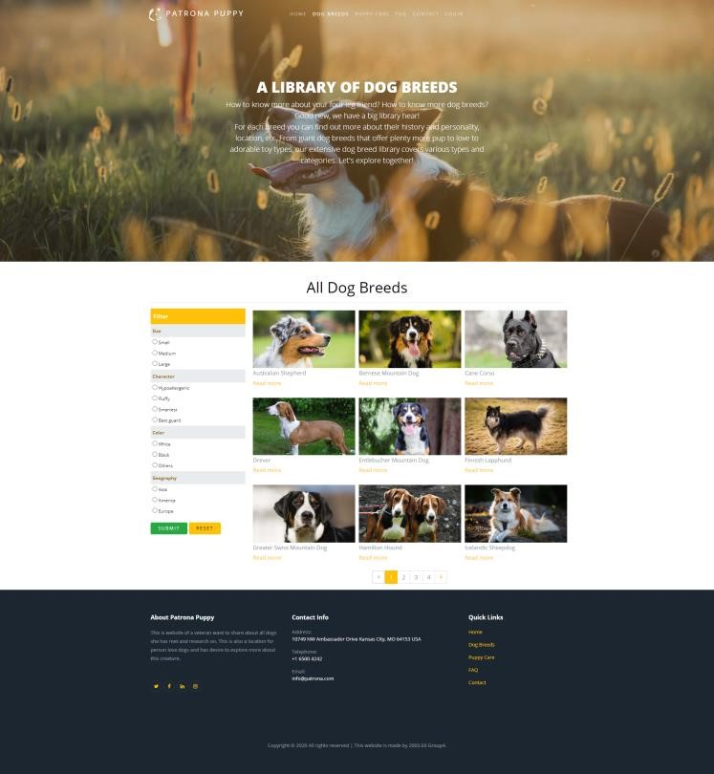 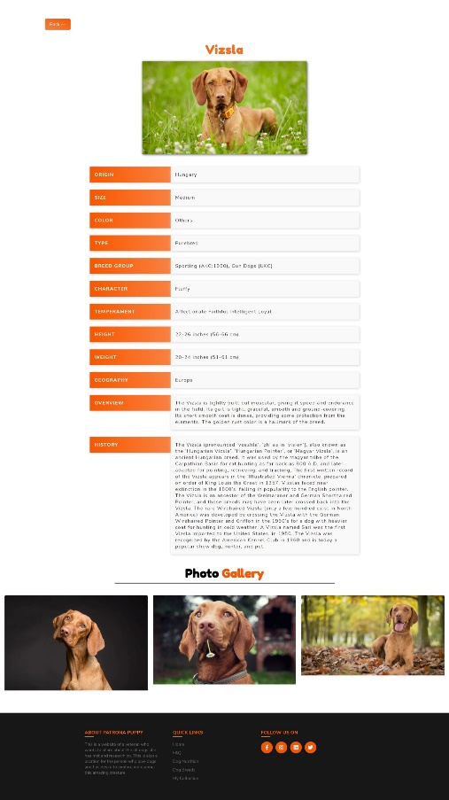

Figure 4 Figure 5

- To make it easier for users to find the product as fast as possible, we created to filter option that users can choose by combined or individual option and then click submit. To reset, they just click Reset button. Look at figure 6 for illustration.

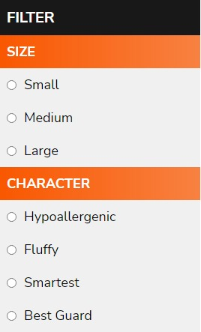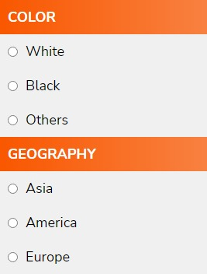

Figure 6

## Puppy care page

This site give users many tips to take care of their dogs better (figure 7). For example, if a person wants to find out how to bath their dog the most effectively they can see the bathing section and click learn more for more details about this topic (Figure 8). In this topic, there is other article they can click learn more on the article they want to read to have more detail.

|  |  |
| --- | --- |
|  |  |
| Figure 7 | |
|  |  |
| Figure 8 | Figure 9 |

## FAQ

In this webpage, we will answer some of the questions user often encounter when taking care of a puppy properly. Check at Figure 10.

|  |  |
| --- | --- |
|  |  |